**Bug report of [WebSiteName]**

[**https://[websiteName] .com/**](https://de.outdoorchef.com/de/)

**Issue 1.**

**Summary:** The position of “Subscribe to Newsletter” button could be middle aligned

**Priority**: Low

**Step to reproduce:**

1. Go to this link [website link]
2. Scroll down to “Subscribe to our newsletter” section
3. Observe the position of The button

**Expected result:**

* Subscribe to our newsletter button could be middle aligned

**Actual Result:**

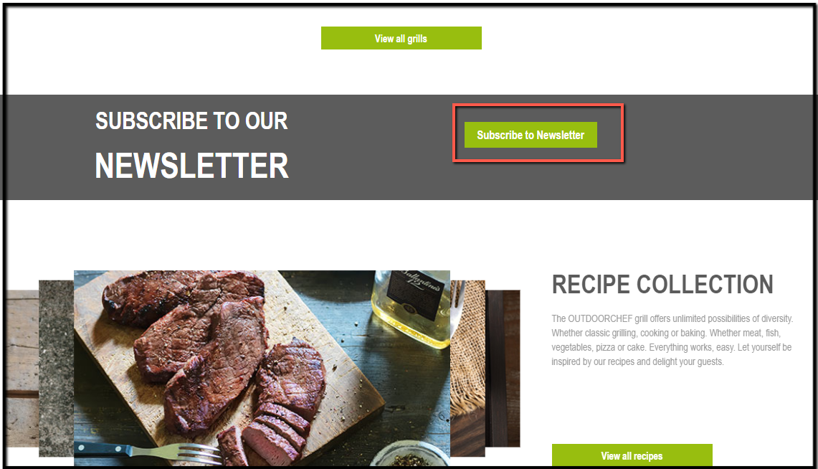

**Issue 2.**

**Summary:** The warning message should not show after filling up the newsletter mandatory fields.

**Priority**: Medium

**Step to reproduce:**

1. Go to this link [website link]
2. Scroll down to “Subscribe to our newsletter” section
3. Click on Subscribe to newsletter
4. Click on Order tips button without fill up the form
5. Then start fill up the form
6. Observe behavior

**Expected result:**

* Warning message should be removed while we start filling up the mandatory field

**Actual Result:**

* Warning message remains after fill up the form until we click on order tips button

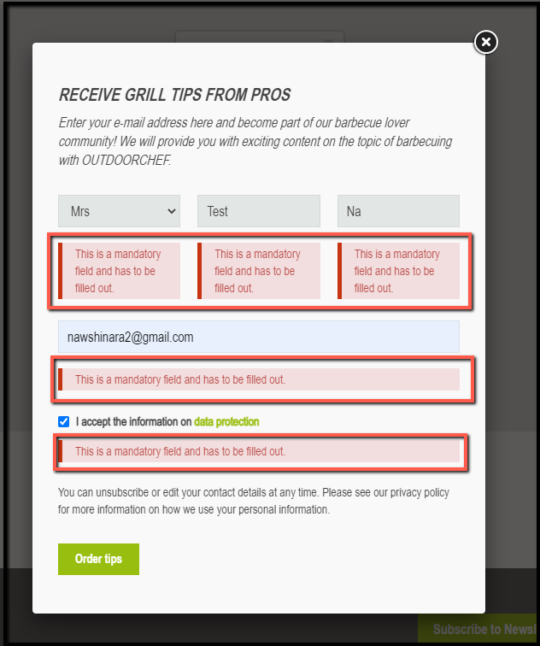

**Issue 3.**

**Summary:** The warning message showing in German language for a blinking of time although English is set

**Priority**: Medium

**Step to reproduce:**

1. Go to this link [website link]
2. Scroll down to “Subscribe to our newsletter” section
3. Click on Subscribe to newsletter
4. Click on Order tips button without fill up the Salutation field
5. Observe behavior

**Expected result:**

* Warning message should show in English while setting the language in English for all fields

**Actual Result:**

* Warning message showing in German for blinking of time

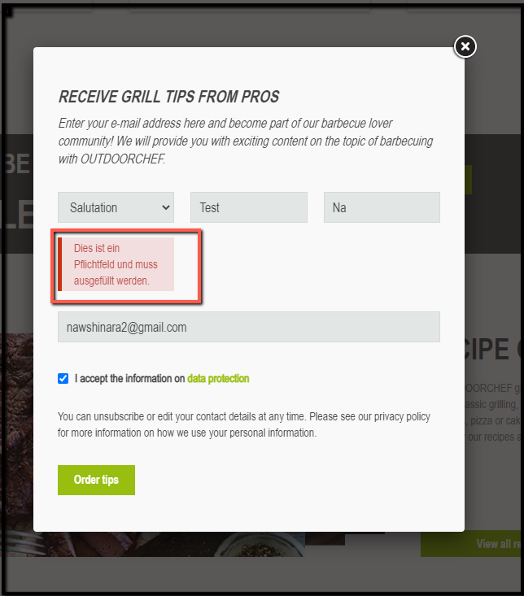

**Issue 4.**

**Summary:** Success pop up message is not properly designed

**Priority**: Low

**Step to reproduce:**

1. Go to this link [website link]
2. Scroll down to “Subscribe to our newsletter” section
3. Click on Subscribe to newsletter -> fill up the form
4. Click on Order tips button
5. Observe success message pop up

**Expected result:**

* The success icon should be aligned with the text
* Success text should be center aligned

**Actual Result:**

* Success icon is not properly aligned with the text
* Success text is not properly aligned with the pop up box

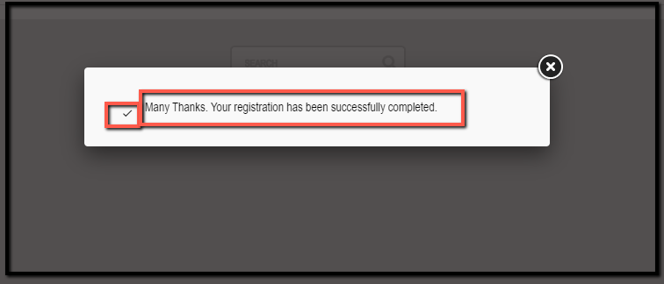

**Issue 5.**

**Summary: All the bullet points should be capitalized**

**Priority**: Low

**Step to reproduce:**

1. Go to this link [website link]
2. Footer -> Privacy
3. Observe the text syntax

**Expected result:**

* All bullet points should be capitalized

**Actual Result:**

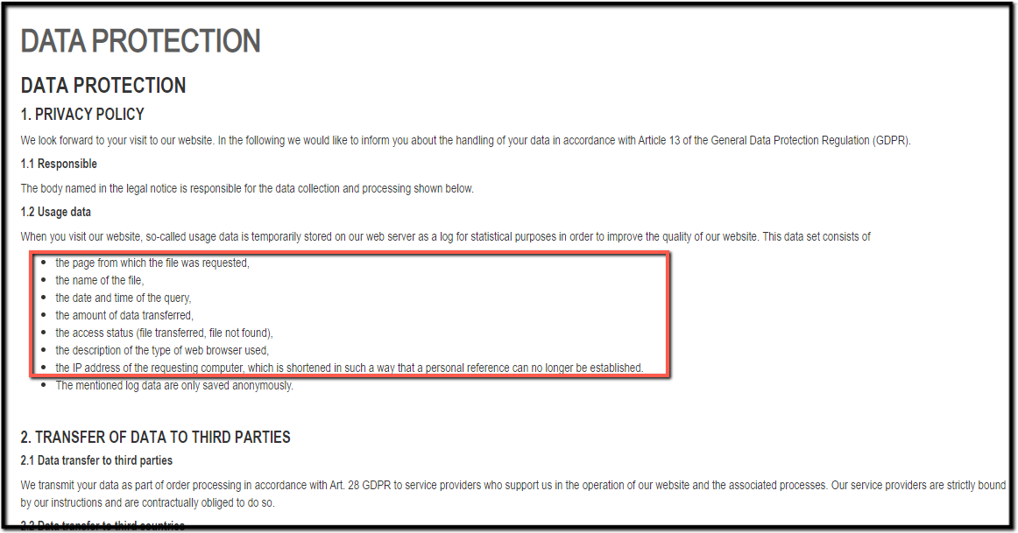

**Issue 6.**

**Summary:** Background is showing blank and search is not working

**Priority**: Medium

**Step to reproduce:**

1. Go to this link [website link]
2. Observe the search portion

**Expected result:**

* There could be a google map
* Clicking on search button could show the searched location

**Actual Result:**

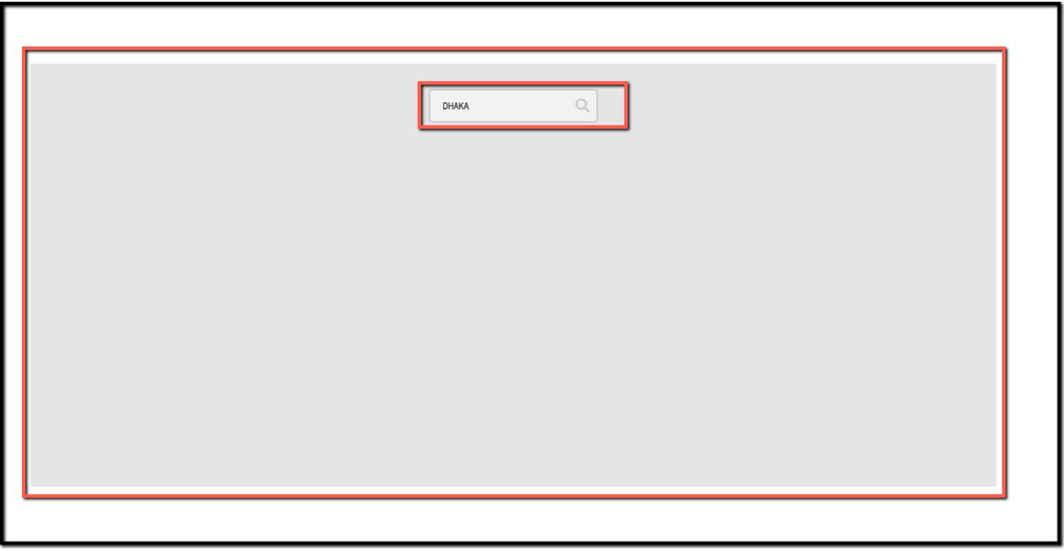

**Issue 7.**

**Summary:** All product images are broken in Grill page

**Priority**: High

**Step to reproduce:**

1. Go to this link [website link]
2. Navigate grills
3. Navigate all the sub menus of grills
4. Observe the product images

**Expected result:**

* Product images should show

**Actual Result:**

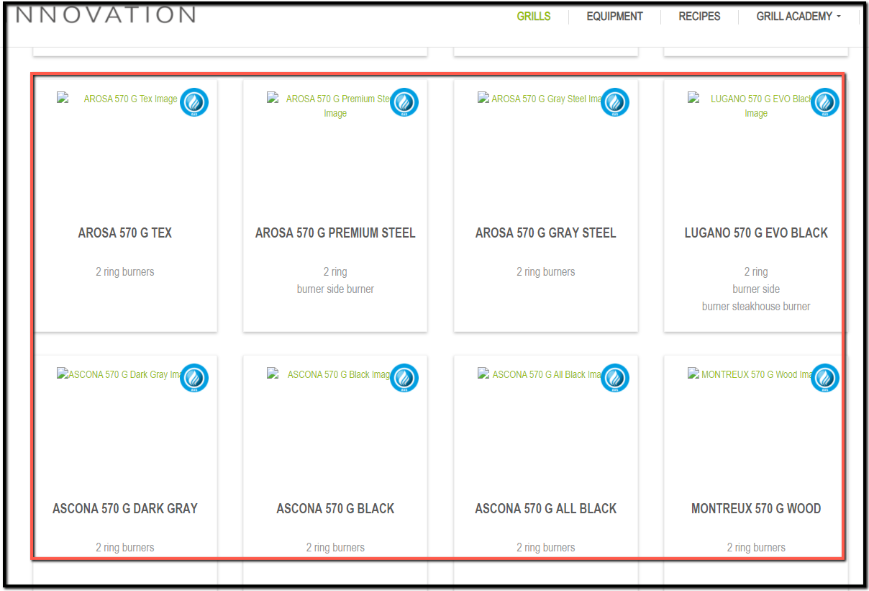

**Issue 8.**

**Summary:** Breadcrumb missing in grill page

**Priority**: Medium

**Step to reproduce:**

1. Go to this link [website link]
2. Navigate grills
3. Navigate all the sub menus of grills
4. Observe the page

**Expected result:**

* Breadcrumb could be shown in grill page

**Actual Result:**

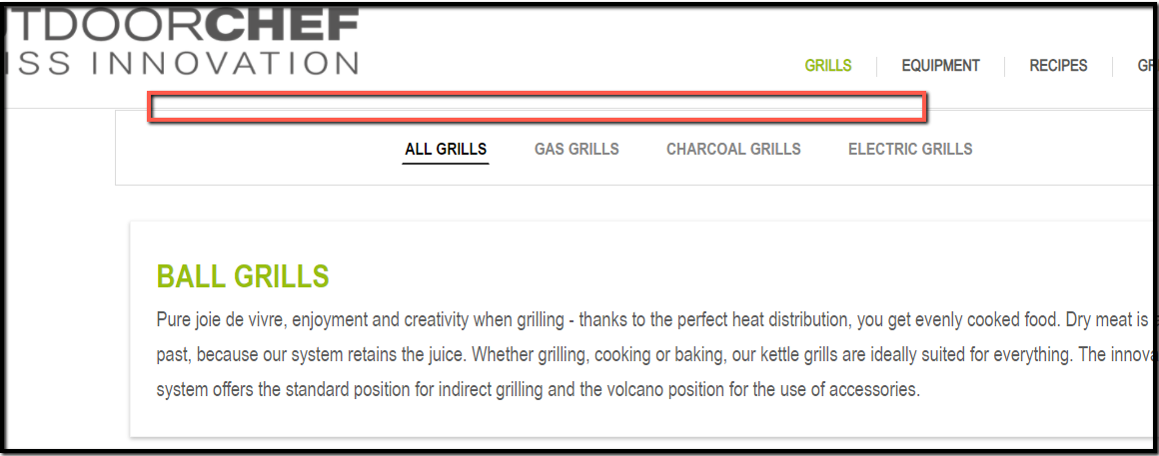

**Issue 9.**

**Summary:** Extra blank box showing for those product where there is no product details

**Priority**: Low

**Step to reproduce:**

1. Go to this link [website link]
2. Navigate grills -> All grills
3. Click on any products -> Arosa 570 G Black Stye
4. Observe the page

**Expected result:**

* The extra box could be removed where there is no details available

**Actual Result:**

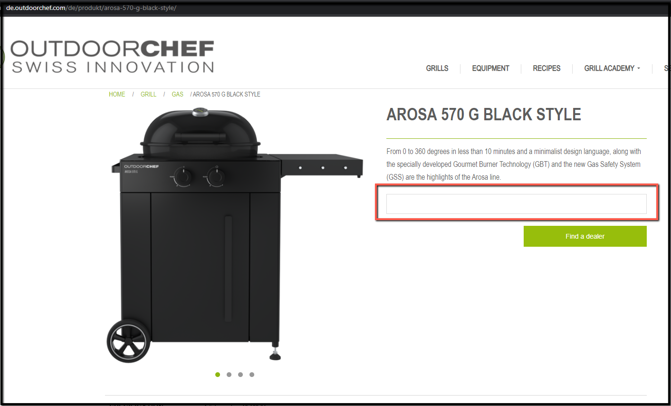

**Issue 10.**

**Summary:** “Find a dealer” button could be right aligned

**Priority**: Low

**Step to reproduce:**

1. Go to this link [website link]
2. Navigate grills -> All grills
3. Click on any products
4. Observe find a dealer

**Expected result:**

* Find a dealer button could be left aligned with the text and description box

**Actual Result:**

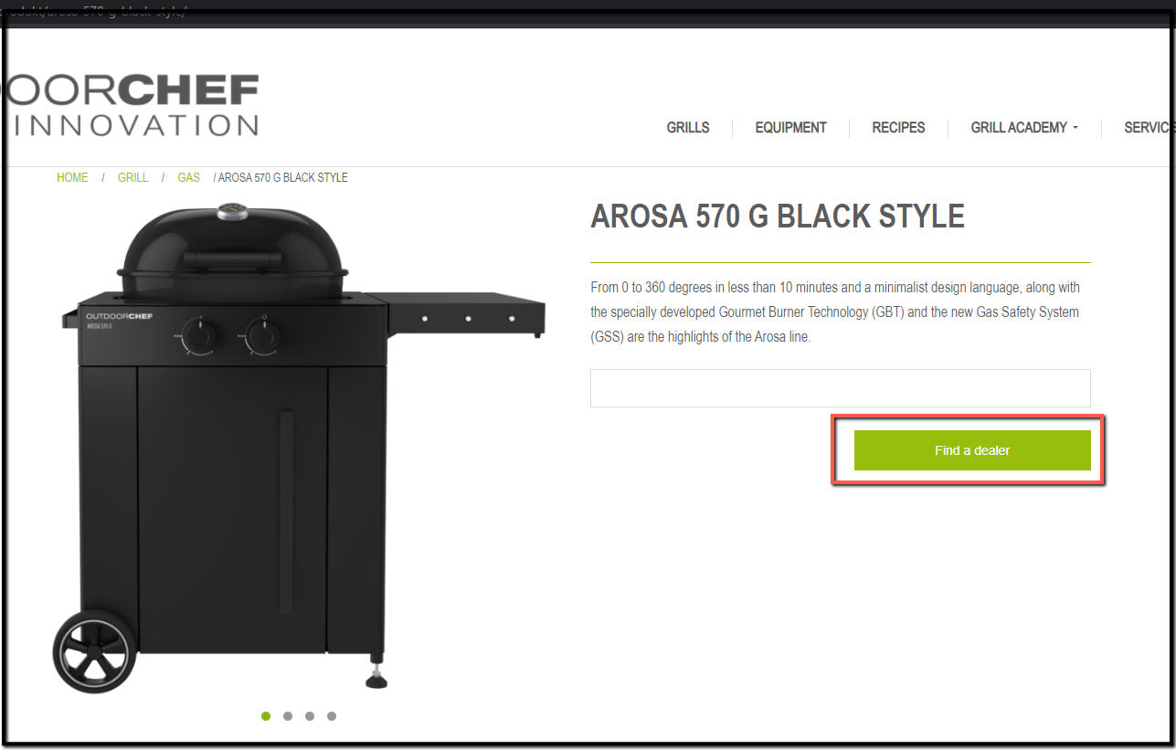

**Issue 11.**

**Summary: Extra space could be remove before review buttons**

**Priority**: Low

**Step to reproduce:**

1. Go to this link [website link]
2. Navigate grills -> All grills
3. Click on any products
4. Observe the review buttons

**Expected result:**

* Space should be removed
* Review buttons should be perfectly aligned with review text

**Actual Result:**

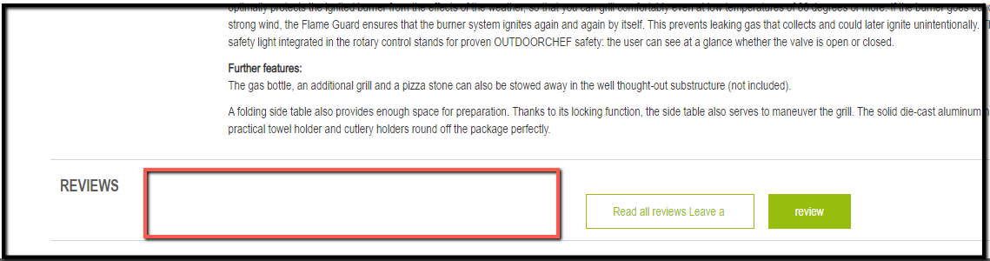

**Issue 12.**

**Summary:** Wrong button text showing

**Priority**: Medium

**Step to reproduce:**

1. Go to this link [website link]
2. Navigate grills -> All grills
3. Click on any products
4. Observe the review buttons

**Expected result:**

* 1st button text should be “Read all reviews”
* 2nd button text should be “Leave a review”

**Actual Result:**

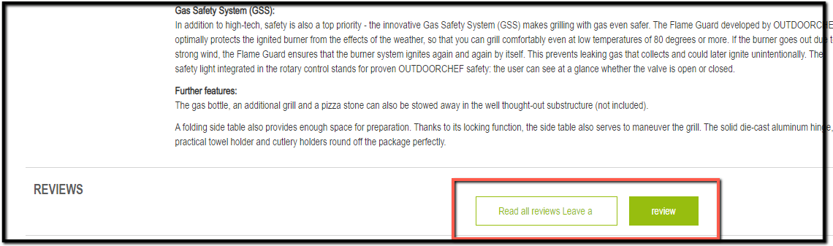

**Issue 13.**

**Summary:** Clicking on “Logged in” button redirecting to home page

**Priority**: Medium

**Step to reproduce:**

1. Go to this link [website link]
2. Navigate grills -> All grills
3. Click on any products
4. Click on review button -> click on logged in button
5. Observe behavior

**Expected result:**

* Clicking on “logged in ” button should redirect to the login page

**Actual Result:**

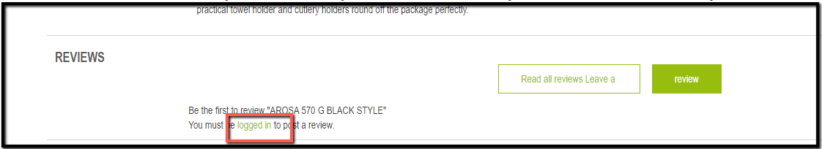

**Issue 14.**

**Summary:** Clicking on Read all reviews is not responding

**Priority**: Medium

**Step to reproduce:**

1. Go to this link [website link]
2. Navigate grills -> All grills
3. Click on read all reviews button
4. Observe behavior

**Expected result:**

* Clicking on Read all reviews button could show no reviews is available if any review is not available for the product

**Actual Result:**

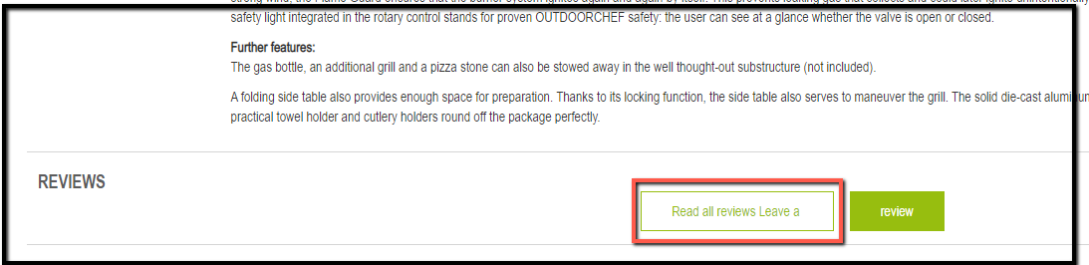

**Issue 15.**

**Summary:** Inconsistent button and hover color showing in

**Priority**: Medium

**Step to reproduce:**

1. Go to this link [website link]
2. Navigate grills -> All grills
3. Click on any products
4. Observe Read all reviews button

**Expected result:**

* Button color and hover color could be same

**Actual Result:**

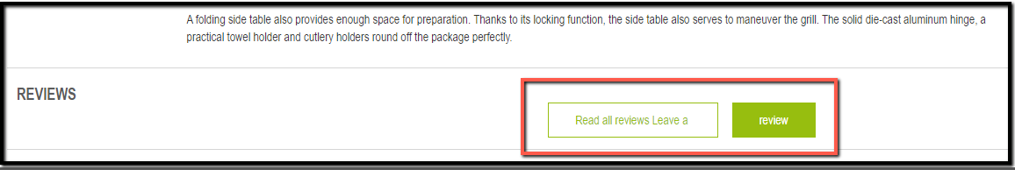

**Issue 16.**

**Summary:** Wrong breadcrumb showing in Equipment page

**Priority**: Medium

**Step to reproduce:**

1. Go to this link [website link]
2. Navigate Equipment
3. Observe the breadcrumb

**Expected result:**

* Breadcrumb could be Home / Accessories

**Actual Result:**

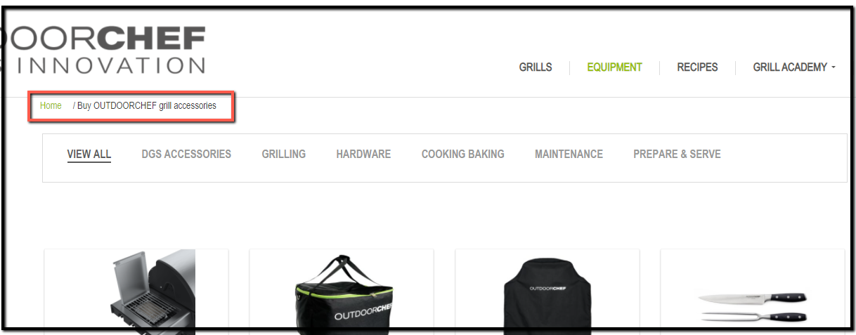

**Issue 17.**

**Summary:** Continue Reading button could be center aligned

**Priority**: Low

**Step to reproduce:**

1. Go to this link [website link]
2. Navigate Equipment
3. Observe the “Continue reading” button

**Expected result:**

* Continue Reading button could be center aligned

**Actual Result:**

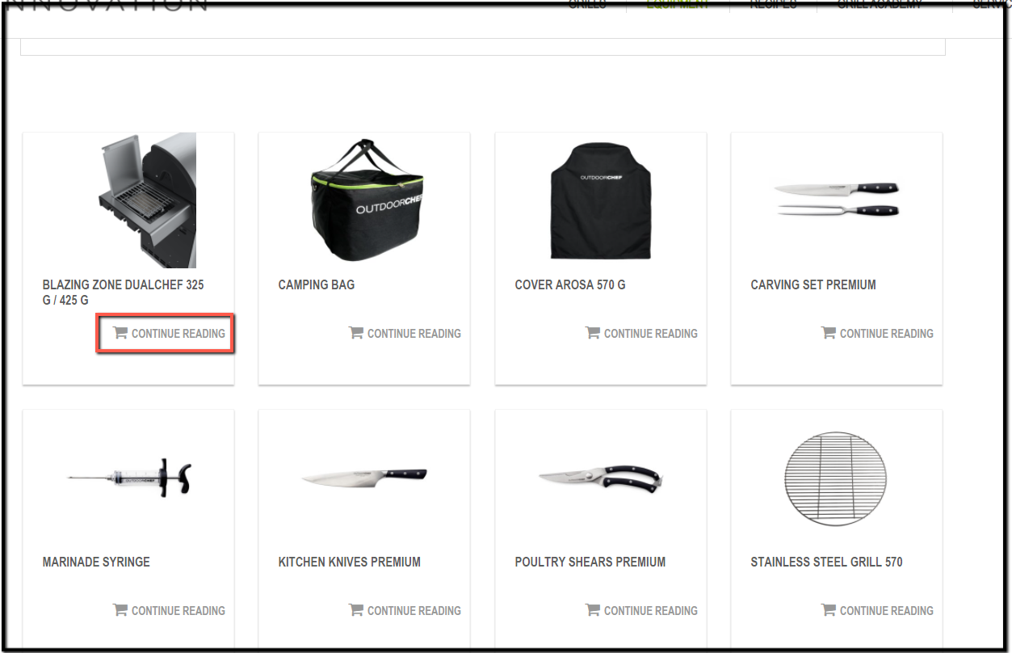

**Issue 18.**

**Summary:** Button name and icon do not match

**Priority**: Medium

**Step to reproduce:**

1. Go to this link [website link]
2. Navigate Equipment
3. Observe the “Continue reading” button

**Expected result:**

* Icon and button name could be matched

**Actual Result:**



**Issue 19.**

**Summary:**The first letter should be capital for “Sort by” filter

**Priority**: Low

**Step to reproduce:**

1. Go to this link [website link]
2. Navigate recipes
3. Observe the “Sort by” text

**Expected result:**

* The filter title should be “Sort by”

**Actual Result:**

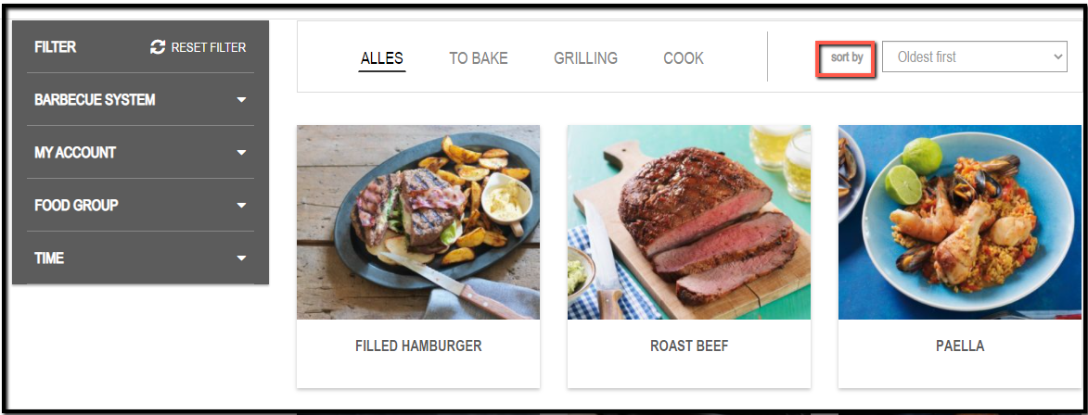

**Issue 20.**

**Summary:**When language is set in English filter name showing “Alles” instead of “All”

**Priority**: Medium

**Step to reproduce:**

1. Go to this link [website link]
2. Navigate recipes
3. Observe the text “Alles”

**Expected result:**

* The filter title should be “All”

**Actual Result:**

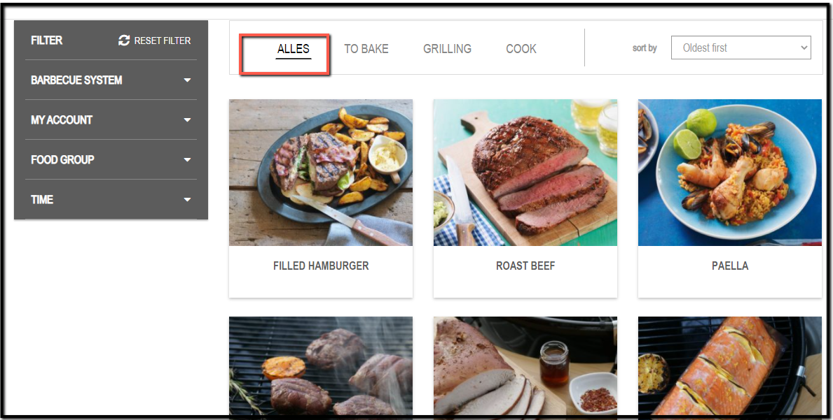

**Issue 21.**

**Summary:** Pdf file not showing when setting serving value to “4” for some recipes.

**Priority**: High

**Step to reproduce:**

1. Go to this link [website link]
2. Navigate recipes -> all ->Click on recipes ex: Rhubarb Asparagus Salmon or Tessiner Risotto
3. Set the value of Serving to “4”
4. Now click on print icon
5. Observe behavior

**Expected result:**

* Pdf file should show for value 4 for specific products

**Actual Result:**

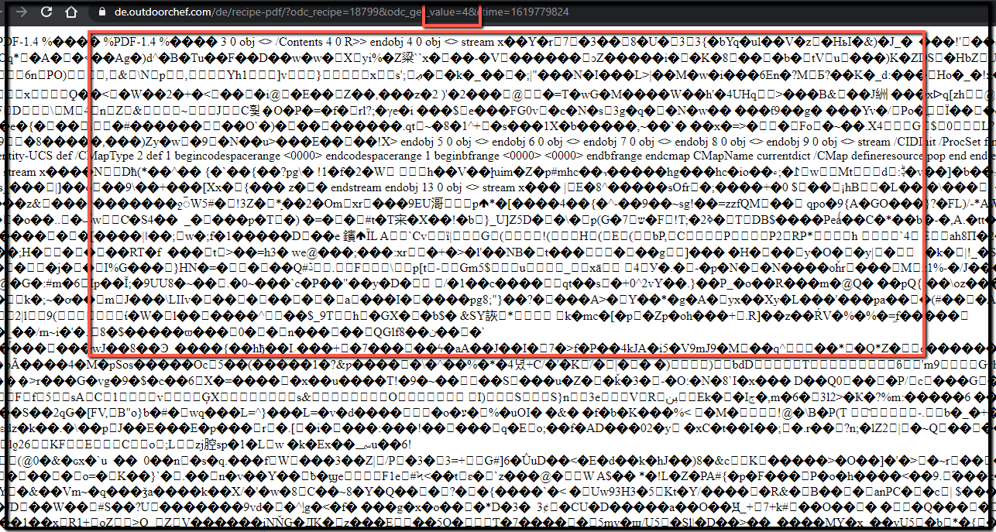

**Issue 22.**

**Summary:**When language is set in English drop down filter option showing “Alles” instead of “All” in BBQ Demonstration page

**Priority**: Medium

**Step to reproduce:**

1. Go to this link [website link]
2. Navigate Grill academy -> Bbq demonstration
3. Observe the drop down option “Alles”

**Expected result:**

* The filter title should be “All”

**Actual Result:**

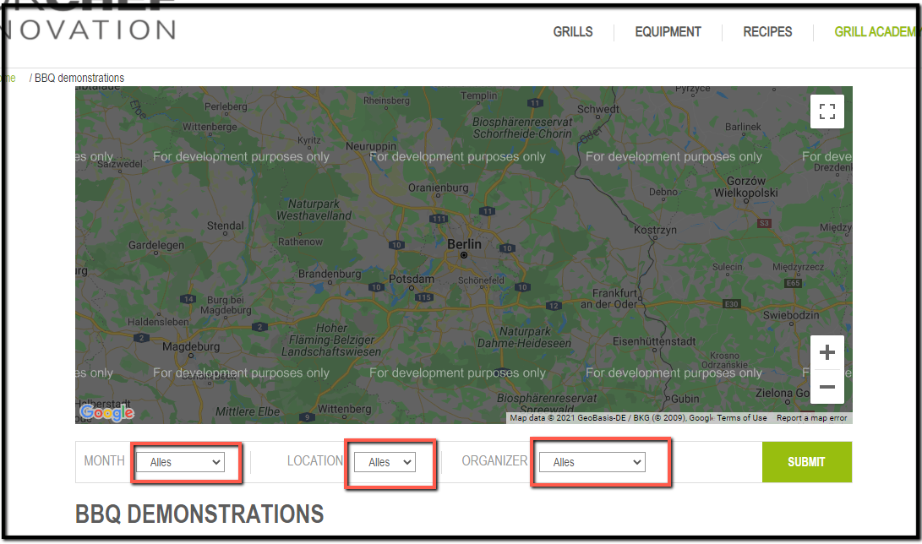

**Issue 23.**

**Summary:** Asterisk sign should be beside the field name in grill registration form

**Priority**: Medium

**Step to reproduce:**

1. Go to this link [website link]
2. Navigate Service-> contact
3. Observe “place of residence” filed name

**Expected result:**

* Asterisk sign should be beside the filed

**Actual Result:**

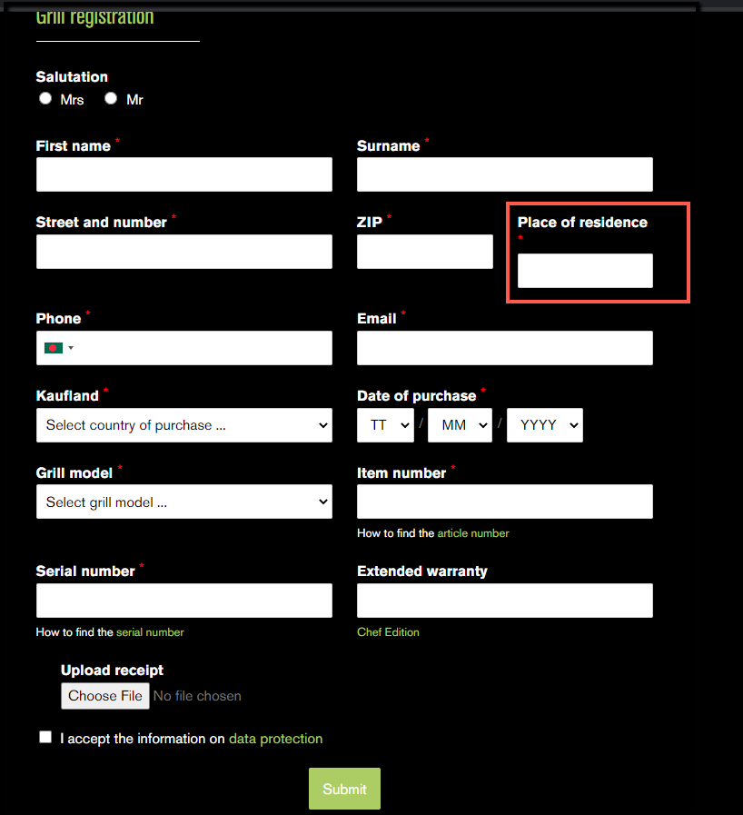

**Issue 24.**

**Summary:** Upload filefiled getting misplaced while click on submit button without fill up the form

**Priority**: Medium

**Step to reproduce:**

1. Go to this link [website link]
2. Navigate Service-> contact
3. Observe “place of residence” filed name

**Expected result:**

* Asterisk sign should be beside the field

**Actual Result:**

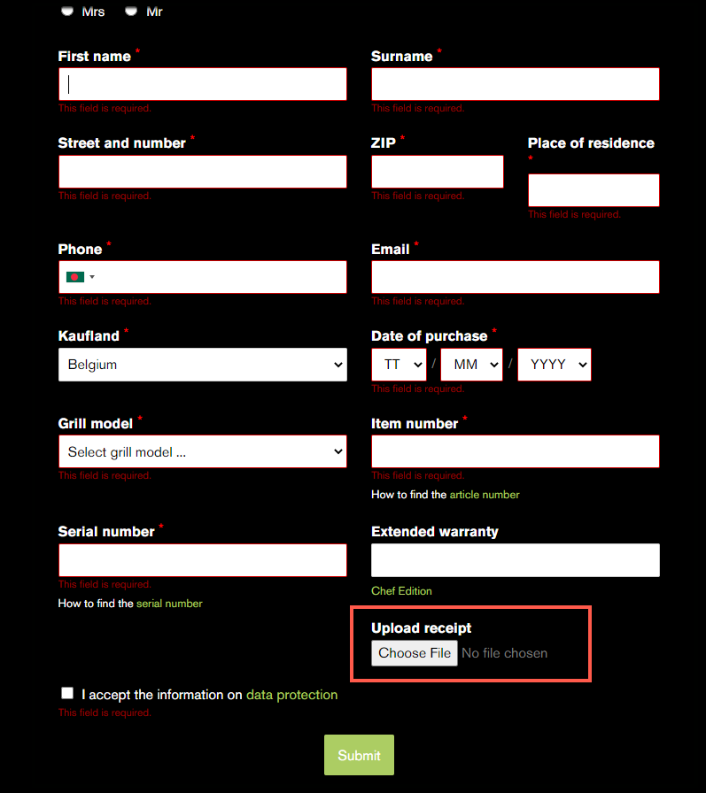

**Issue 25.**

**Summary:** Inconsistent date syntax showing for date of purchase filed

**Priority**: Medium

**Step to reproduce:**

1. Go to this link [website link]
2. Navigate Service-> contact
3. Observe “date of purchase” filed name

**Expected result:**

* Asterisk sign should be beside the field

**Actual Result:**

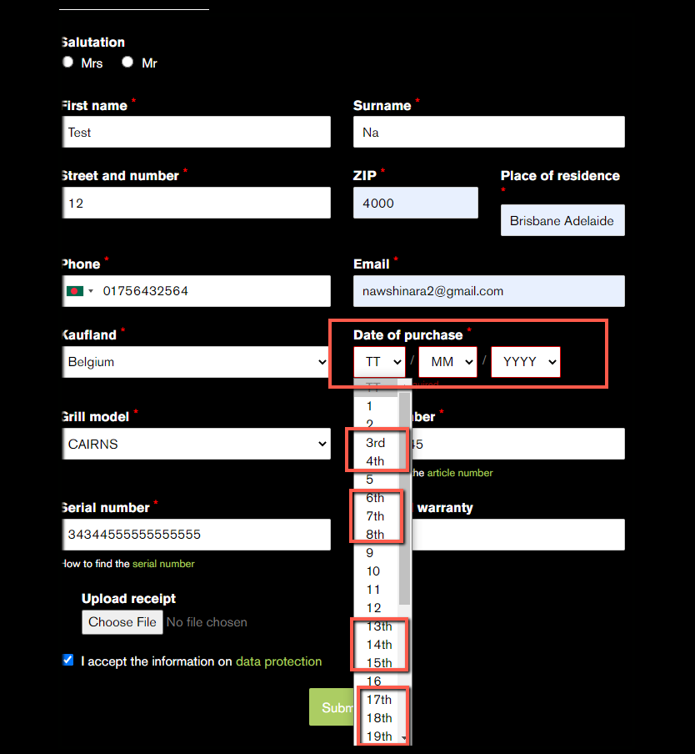

**Issue 26.**

**Summary:** Inconsistent text showing for mandatory fields,could show asterisk sign

**Priority**: Medium

**Step to reproduce:**

1. Go to this link [website link]
2. Navigate Service-> warranty
3. Observe mandatory field

**Expected result:**

* Asterisk sign should be beside the mandatory fields

**Actual result:**

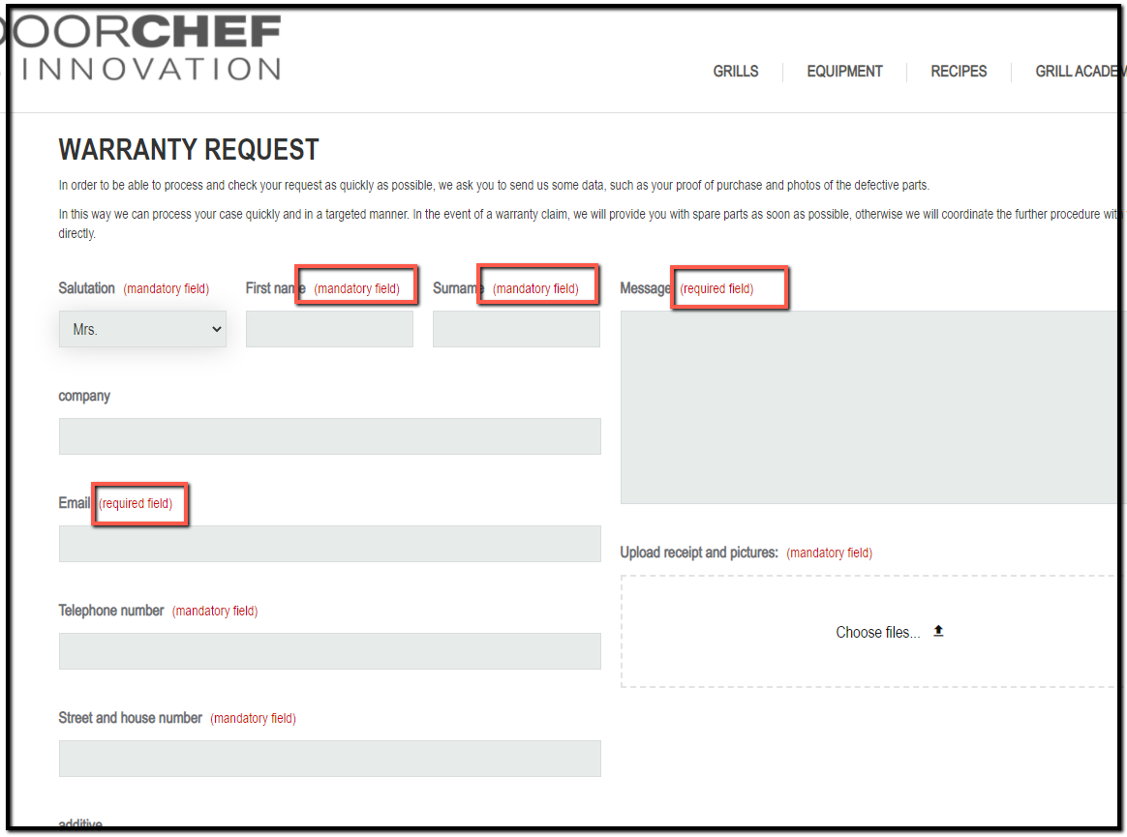

**Issue 27.**

**Summary:** Inconsistent text syntax showing for field name

**Priority**: Low

**Step to reproduce:**

1. Go to this link [website link]
2. Navigate Service-> warranty
3. Observe field name

**Expected result:**

* The 1st letter of All fields name should be capital

**Actual Result:**

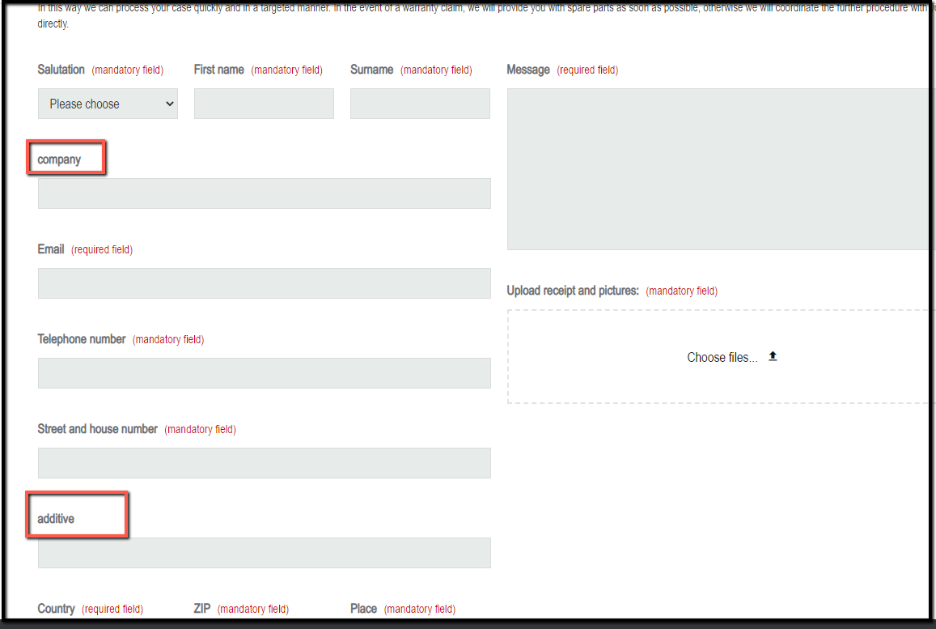

**Issue 28.**

**Summary:** When we search any product filter name showing double

**Priority**: Medium

**Step to reproduce:**

1. Go to this link [website link]
2. Click on search -> search anything
3. Observe the filters

**Expected result:**

* Recipes filter name should be shown only once

**Actual Result:**

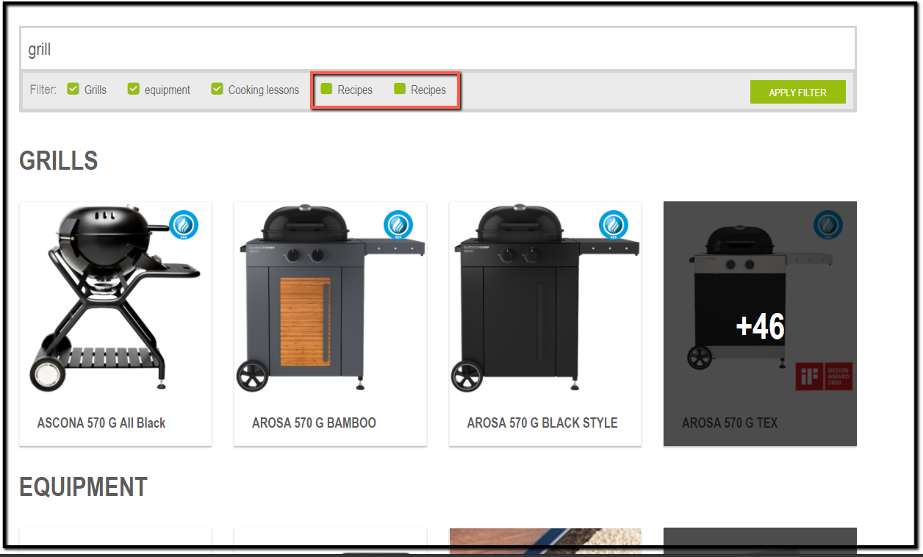

**Issue 29.**

**Summary:** Equipment filter title should be capitalized

**Priority**: Low

**Step to reproduce:**

1. Go to this link [website link]
2. Click on search -> search anything
3. Observe the filters title

**Expected result:**

* Equipment filter title should be capitalized

**Actual Result:**

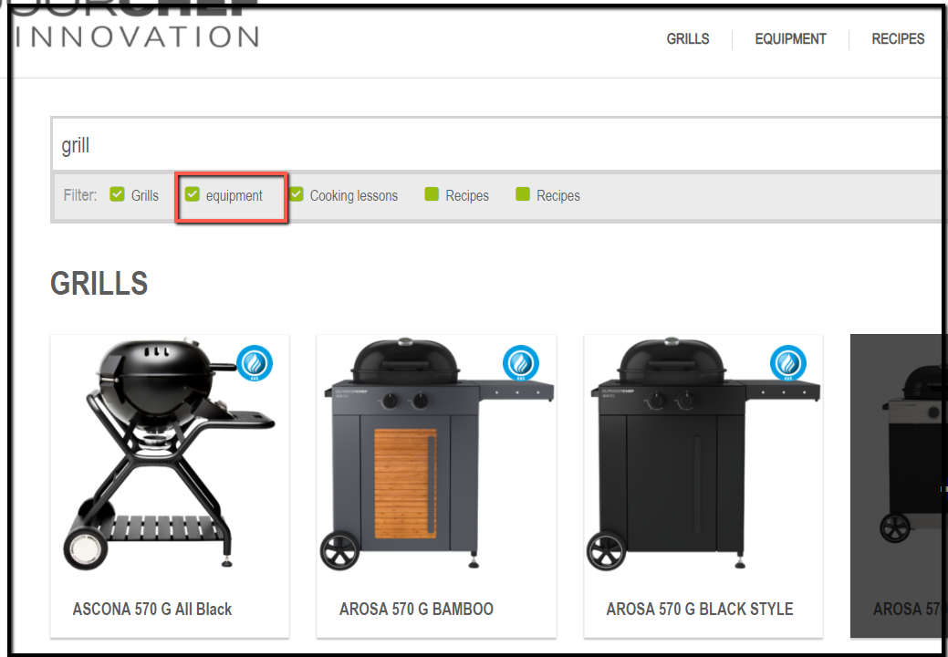

**Issue 30.**

**Summary:** Images broken

**Priority**: Medium

**Step to reproduce:**

1. Go to this link [website link]
2. Header -> Click on globe icon
3. Observe behavior

**Expected result:**

* Images should not be broken

**Actual Result:**

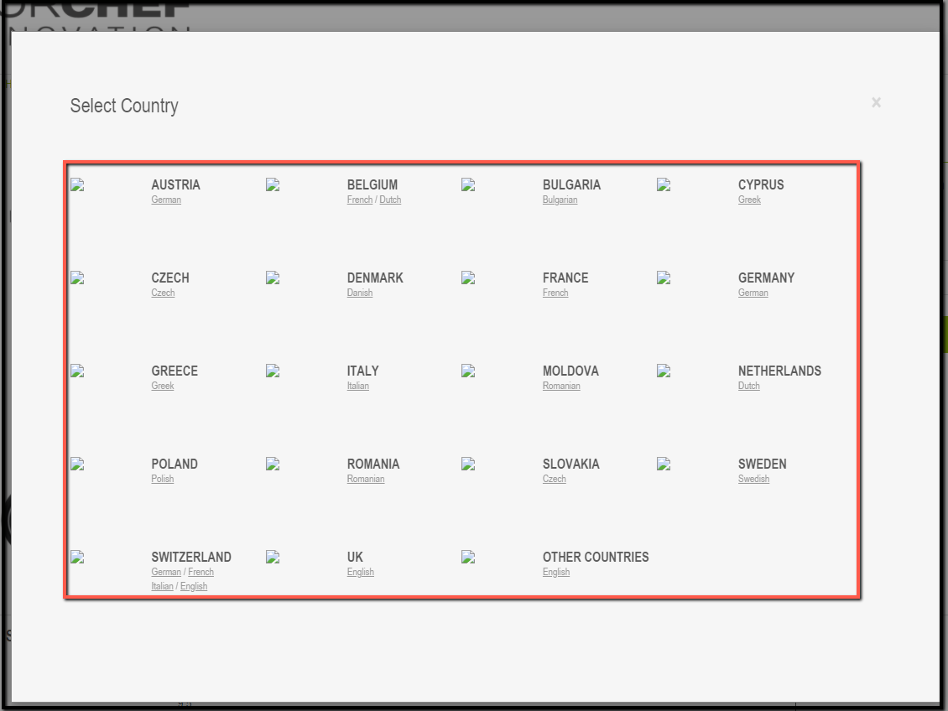

**Issue 31.**

**Summary:** View product pop up broken

**Priority**: Medium

**Step to reproduce:**

1. Go to this link [website link]
2. 2nd Banner -> learn more
3. Click on any product
4. Observe behavior

**Expected result:**

* Full view product pop up should be shown

**Actual Result:**

* The front part of pop up is getting cut

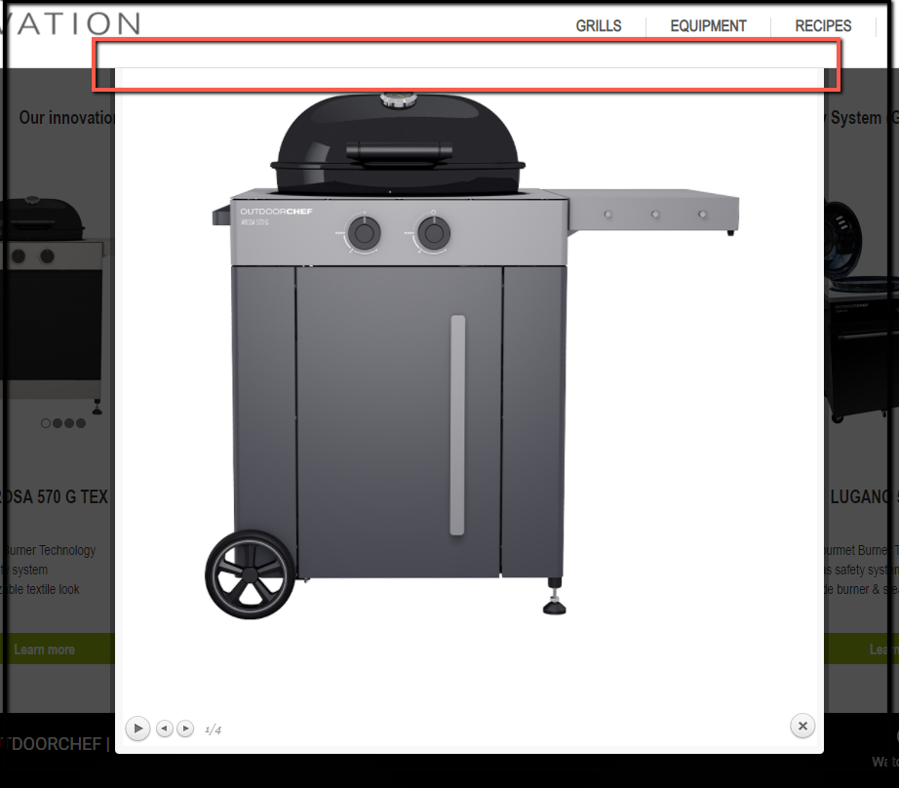

**Issue 32.**

**Summary:** Need validation for text fields

**Priority**: Medium

**Step to reproduce:**

1. Go to this link [website link]
2. Service -> warranty
3. Observe the text field

**Expected result:**

* Need validation for serial number
* Need validation Zip filed

**Actual Result:**

* No warning message showing for serial number
* No warning message showing for zip

